About Me and My School Key Stage 1
Results July 2018
 | Yes | Don’t Know | No
1.Do you enjoy being in school? | 99% | 1%
2.Are your lessons interesting? | 98% |  | 2%
3.Do you know what to do when you get stuck? | 96% |  | 4%
4. Do you have to work hard? | 98% |  | 2%
5. Do teachers show you how to improve your work? | 97% | 2% | 1%
6. Do you have lots of friends in school? | 97% | 1% | 2%
7. Is there an adult you go to if you are worried in school? | 99% | 1%
8. Do you feel safe in school? | 100%
9. Do you think home learning helps you? | 93% | 3% | 3%
10. Do you think our children are well behaved? | 94% | 6%
Thank you for 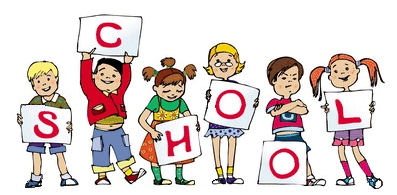your help!!
your help.

